
Product Dissection for Uber

Company Overview

Hey everyone, I have chosen Uber for this case study. Started back in 2009 by Travis Kalanick and Garrett Camp, Uber completely changed how we get around. What began as a simple way to get a cab in San Francisco has grown into this massive global platform handling rides, food delivery, even freight. They operate in 10,000+ cities now, and it's fascinating how they manage millions of trips daily. Acquired by... wait no, they went public in 2019. Their whole thing revolves around connecting riders and drivers instantly while solving real urban mobility headaches.

Product Dissection and Real-World Problems Solved by Uber

Uber tackles some massive everyday frustrations. First off, hailing a cab in busy cities - we've all stood on the street waving futilely while taxis zoom by. Uber's app-based matching solves this by showing available cars nearby with ETAs, pricing upfront, and one-tap booking.
Then there's unpredictable pricing and wait times. Traditional taxis have meters that can surprise you, and you never know how long you'll wait. Uber's dynamic pricing (surge) and real-time tracking give transparency - you see the fare before booking and watch your driver approach.
For drivers, empty miles, and low earnings. Uber's algorithm matches them efficiently, shows demand hotspots via the app, and handles payments automatically. Safety is huge too - background checks, trip sharing, emergency buttons.
Finally, cashless convenience in cash-heavy markets. Uber pushes digital payments, ratings both ways, and even multi-stop trips now. These features make urban life smoother.

Case Study: Real-World Problems and Uber's Approach

Case 1: Late Night Airport Run (Problem: Unreliable Taxi Availability)
Picture this: 2 AM at Mumbai airport, no taxis in sight, sketchy prepaid stands with long queues. Rider opens Uber - 3 cars available, 7-min ETA, ₹800 fare shown upfront. Driver arrives, shares live location, rider shares trip with family. Solution: Real-time matching + GPS tracking eliminated the "will a cab come?" anxiety.

Case 2: Surge Pricing During Rain (Problem: Demand-Supply Imbalance)
Monsoon hits Delhi, everyone needs rides, taxis vanish. Uber shows "Surge: 2.3x", prices adjust, more drivers come online seeing high-demand zones. Rider waits 2 mins vs 30+. Approach: Algorithmic pricing incentivizes supply without government regulation.

Case 3: Driver Safety Post Assault Reports (Problem: Trust Issues)
Early Uber had incidents. Now: PIN verification before pickup, SOS button connects to police, automatic trip recording. Riders rate drivers, low ratings suspend accounts. User-centric fix: Data-driven trust via ratings + verification.

Case 4: Payment Friction in India (Problem: Cash Dependency)
Cash-on-delivery culture. Uber pushed UPI/Wallets with incentives, now 80%+ cashless. Split fares, scheduled rides added. Evolution: Gradual feature rollout based on market feedback.
Uber's strength? Constant iteration - they A/B test everything, use rider/driver feedback loops.

Top Features of Uber
- Real-Time Ride Matching - GPS-powered, shows cars/ETAs instantly
Uber uses GPS and real-time data to instantly match riders with nearby available drivers. This reduces waiting time and ensures efficient use of vehicles based on location and availability.
- Live Tracking & ETA - Rider sees driver approach, exact arrival time
Once a ride is confirmed, riders can track the driver’s location live on the map. The system continuously updates the Estimated Time of Arrival (ETA), improving transparency and trust.
- Dynamic Pricing (Surge) - Adjusts based on demand/supply
Uber adjusts ride prices based on real-time demand and supply conditions. During peak hours or high demand, surge pricing helps balance demand by encouraging more drivers to come online.
- Ratings & Reviews - Bidirectional trust system
Both riders and drivers rate each other after every trip. This two-way feedback system promotes good behaviour, accountability, and overall service quality on the platform.
- Payments & Receipts - Cashless, split bills, trip history
Uber offers cashless payment options such as UPI, cards, and wallets. Riders receive detailed digital receipts and can view complete trip and payment history within the app.
- Ride Options - UberX, Pool, Black, Auto (2-wheelers in India)
Uber provides multiple ride categories like UberX, Uber Pool, Uber Black, and two-wheelers in India. This allows users to choose rides based on comfort, price, and urgency.
- Safety Features - SOS, trip sharing, driver docs verification
Uber includes safety tools such as SOS emergency button, live trip sharing, and driver document verification. These features enhance rider and driver security throughout the journey.
- Multi-Destination - Add stops mid-trip
Uber allows riders to add multiple stops during a trip. This feature is useful for errands or shared rides and ensures fare recalculation based on updated routes.

Schema Design Based on Top Features
Designed this schema thinking about Uber's core flow: Rider requests → Match driver → Trip → Payment → Rate.

User Entity (Riders + Drivers share base):
- user_id (Primary Key): A unique identifier for each user.
- Name: The user's full name as displayed on their profile.
- Phone: Holds the user’s mobile number, mainly used for login verification, ride communication, and important alerts.
- Email: The user's email address for account-related communication.
- user_type (rider/driver/both): Defines the role of the user on the platform, allowing the same account to act as a rider, a driver, or both.
- created_at: Records the date and time when the user account was created on the platform.
- is_verified (bool): Indicates whether the user has successfully completed verification, such as phone or identity verification.
Driver Entity:
- driver_id (Primary Key): A unique identifier for each driver, used as the primary key of the table.
- user_id (Foreign Key): A foreign key that links the driver to the corresponding user record.
- license_no: Stores the driver’s official driving license number for legal and safety verification.
- vehicle_id (FK): References the vehicle assigned to the driver, connecting driver and vehicle data.
- current_status (online/offline/busy): Shows the driver’s availability status for accepting new ride requests.
- rating_avg: Maintains the driver’s average rating based on rider feedback.
- total_trips: Tracks the total number of trips completed by the driver.

Vehicle Entity:
- vehicle_id (Primary Key): A unique identifier assigned to each vehicle in the system to avoid duplication and enable accurate tracking.
- make_model: Stores the brand and model of the vehicle, helping riders understand what type of car will arrive.
- license_plate: Contains the vehicle’s registration number, which is used for identification and verification purposes.
- Color: Records the colour of the vehicle so riders can easily recognize it during pickup.
- Capacity: Specifies the maximum number of passengers the vehicle can carry safely.
- vehicle_type (UberX/Pool etc.): Defines the service category of the vehicle, which helps determine pricing, ride eligibility, and user selection.

Trip Entity (Core table!):

- trip_id (PK)
- rider_id (FK to User)
- driver_id (FK to Driver)
- pickup_lat, pickup_lng
- drop_lat, drop_lng
- status (requested/accepted/arrived/completed/cancelled)
- requested_at
- accepted_at
- started_at
- ended_at
- distance_km
- duration_min

Fare Entity:

- fare_id (PK)
- trip_id (FK)
- base_fare
- distance_fare
- time_fare
- surge_multiplier
- total_fare
- currency

Payment Entity:
- payment_id (PK)
- trip_id (FK)
- amount
- payment_method (upi/card/cash)
- status (paid/pending/refunded)
- paid_at

Rating Entity:

- rating_id (PK)
- trip_id (FK)
- rider_rating (1-5)
- driver_rating (1-5)
- rider_comment
- driver_comment
- rated_at

Location_Update Entity (Real-time tracking):
- update_id (PK)
- trip_id (FK)
- lat, lng
- timestamp
Relationships:
- User 1:M Driver (one user can be driver)
- Driver 1:M Vehicle
- User 1:M Trip (as rider)
- Driver 1:M Trip
- Trip 1:1 Fare
- Trip 1:1 Payment
- Trip 1:1 Rating (post-trip)
- Trip 1:M Location_Update
Rationale Behind the Design
- Why Trip as central entity? Every feature revolves around trips - matching, tracking, pricing, payments all tie back here. Scalable for millions daily.

- Separate Driver/Vehicle? Drivers switch cars, vehicles have specs affecting ride type/pricing.

- Location_Update denormalized? Real-time needs speed, not joins during trip.

- Surge_multiplier in Fare? Historical analysis for pricing optimization.

- Ratings linked to Trip? Contextual feedback, prevents spam.

- Designed for high writes (live updates) + high reads (history/analytics). Indexes on lat/lng for geo-queries, status for active trips.

ER Diagram

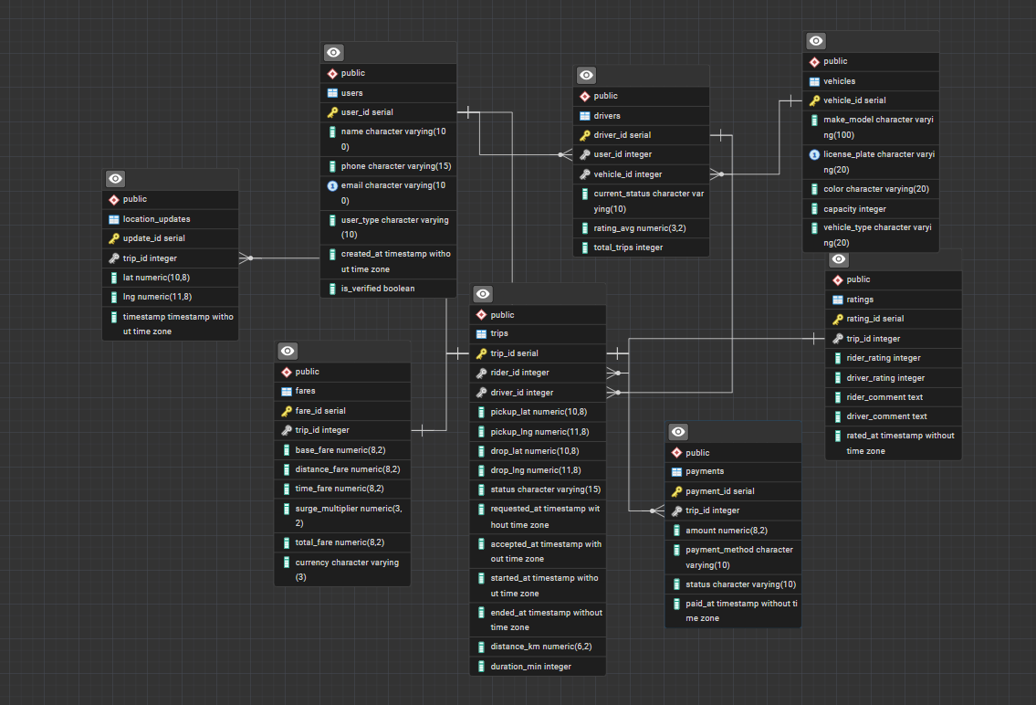

Conclusion
Breaking down Uber showed me how data drives everything - from matching riders/drivers in seconds to surge pricing fairness. The schema mirrors real-world flow: users → trips → money → feedback loop. Challenges like scale (1M+ trips/hour peak) and real-time (GPS every 5s) demand normalized-yet-performant design. Safety/ratings build trust at scale.
This wasn't just theoretical - thought about India-specific stuff like UPI, bikes (Uber Moto), traffic surges in monsoons. Schema supports Uber Eats expansion too (add restaurant/delivery entities). Loved connecting product features to DB choices!
Skills gained: Entity modelling, cardinality thinking, denormalization trade-offs. Ready for real schema design interviews.

